**Grove - Magnetic Switch**

窗体顶端

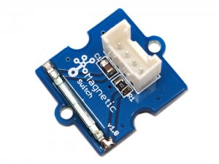

http://www.seeedstudio.com/depot/includes/templates/pure_green/images/next_l.gif

* [http://www.seeedstudio.com/depot/bmz_cache/c/c960bf6aa1e42897b7cce4a6bd886bd0.image.55x41.jpg](http://www.seeedstudio.com/depot/images/product/magnetic%20Switch.jpg)
* [http://www.seeedstudio.com/depot/bmz_cache/5/5183ec68ef26b6dfc4f51d5cb7b6cd28.image.55x41.jpg](http://www.seeedstudio.com/depot/images/product/magnetic%20Switch_01.jpg)

http://www.seeedstudio.com/depot/includes/templates/pure_green/images/next_r.gif

* **Price:**

$2.90  [(Price Feedback)](javascript:void())

* **SKU:**

COM11335P

* **Weight:**

5Gram

* **Units in Stock**

15

* **Designed by:**

[Seeed Studio](http://www.seeedstudio.com/)



[Other products from designer](http://www.seeedstudio.com/depot/seeed-studio-m-23.html)

* **Quantity:** Max: 15  
  
* [Add to Wish List](http://www.seeedstudio.com/depot/index.php?main_page=un_wishlist&products_id=744&cPath=156_160&action=un_add_wishlist)

Description

This is a Grove interface compatible Magnetic switch module. It is based on encapsulated dry reed switch CT10. CT10 is single-pole, single throw (SPST) type, having normally open ruthenium contacts. The sensor is a double-ended type and may be actuated with an electromagnet, a permanent magnet or a combination of both. The magnetic switch is a wonder tool for designers who would like to turn a circuit on and off based on proximity.

**Features**

* Grove compatible interface
* 2.0cm x 2.0cm twig module
* Minimum external parts
* 10W rating
* Rugged encapsulation

**Documents**

Please visit our[wiki page](http://garden.seeedstudio.com/index.php?title=Twig_-_Magnetic_Switch) for more info about this product. It will be appreciated if you can help us improve the documents, add more demo code or tutorials. For technical support, please post your questions to our [forum](http://www.seeedstudio.com/forum).

窗体底端